|  |  |  |
| --- | --- | --- |
|  |  |  |
|  |  |  |
|  | **21/08/2023** |  |
|  |
| **Analysis on** |
| Adidas Sales Data  By  **JAGRUTHI MANCHI SARAF** |
|  | **IMPOSSIBLE IS NOTHING** |  |
|  |  |  |
|  |  |  |

**ACKNOWLEDGEMENT**

This satisfaction that accompanies the completion of any task would be incomplete without the mention of the people who made it possible and whose constant encouragement and guidance has been a source of inspiration throughout the course of this project. We take the opportunity to express our gratitude to all this who have helped in this project.

I deeply gratitude and sincere thanks to **Mr.** **NILANJAN CHATTERJEE ,** dean, Ethames College, Hyderabad, for having provided facilities to undertake and complete the project.

I deeply indebtedto **Mr. Randeep Reddy,** Machine Learning Engineer, Sr Data Quality Analyst at 9aisolutions, for his effable encouragement he provided.

I extend my gratitude and sincere thanks to my Project Coordinator **Mr. Afsaar** for his help and suggestions, which made this project successful

Finally, we express our immense gratitude with pleasure to other individuals who have either directly or indirectly contributed to our need at right time for the development and success of this work

**Jagruthi Manchi Saraf**

**ABSTRACT**

An Adidas sales dataset is a collection of data that includes information on the sales of Adidas products. This type of dataset may include details such as the number of units sold, the total sales revenue, the location of the sales, the type of product sold, and any other relevant information.

Adidas sales data can be useful for a variety of purposes, such as analyzing sales trends, identifying successful products or marketing campaigns, and developing strategies for future sales. It can also be used to compare Adidas sales to those of competitors, or to analyze the effectiveness of different marketing or sales channels.

There are a variety of sources that could potentially provide an Adidas sales dataset, including Adidas itself, market research firms, government agencies, or other organizations that track sales data. The specific data points included in an Adidas sales dataset may vary depending on the source and the purpose for which it is being used.

**INDEX**

|  |  |
| --- | --- |
| **Serial no.** | **context** |
| 1 | Introduction |
| 1.1 | About dataset |
| 1.2 | About Adidas Company |
| 2 | Tools used in this project |
| 3 | Unified Modeling Language |
| 4 | Analysis phases |
| 4.1 | Ask Phase |
| 4.2 | Prepare Phase |
| 4.3 | Process Phase |
| 4.4 | Analyze Phase |
| 4.5 | Share Phase |
| 5 | My Dashboard |
| 6 | Insights |

**INTRODUCTION**

**ABOUT ADIDAS:**

German brand adidas is one of the world’s two biggest sportswear companies alongside Nike, but its greatest historical rival was fraternal. Shoemaking brothers Adolf and Rudolf Dassler founded Gebrüder Dassler Schuhfabrik in 1924 before becoming estranged and founding their own companies, adidas and PUMA. The Brand with the Three Stripes is not only a behemoth in sports such as football; its Run-DMC-driven popularity in ’80s NYC helped adidas become a lifestyle giant, too.

The name adidas comes from its founder’s name, Adolf, and its abbreviation, “Adi”.Adidas is one of the most famous German Clothing brands that manufactures and sells sportswear, founded by Adolf “Adi” Dassier in Herzogenaurach, Germany, in 1949. Adidas shoes are made in three different locations. First, adidas shoes are designed and tested with different materials in the adidas HQ in Herzogenaurach, Germany. Then, most of the adidas shoe production is done in their manufacturing facility in Indonesia. Additionally, adidas has a “Speed factory” in Bavaria, where high-speed production is based on and customized to athletes’ data.

Adidas’ tagline is **“Impossible Is Nothing,”** which communicates the brand’s passion for sport and the desire to be the pioneering one-stop shop for athletes.

**ABOUT ADIDAS DATASET:**

An Adidas sales dataset is a collection of data that includes information on the United States sales of Adidas products. The 9625 rows and 13 columns of the Adidas dataset were acquired from Kaggle. This dataset includes the cities and states of the United States. We have six retailers, and they are Foot Locker, Amazon, Kohl’s, Sports Direct, Walmart, and West Gear. In US sales data, we have 52 states and five regions, i.e., the Midwest, Northeast, South, Southeast, and West. This dataset contains six products of the Adidas Company: men’s apparel, women’s apparel, men’s street footwear, women’s street footwear, men’s athletic footwear, and women’s athletic footwear. The dataset also contains the price per unit. Price per unit is the selling price of Adidas for each product to retailers. Unit sales are how many units or products have been sold to retailers; total sales are the multiplication of unit sales and price per unit. Operating profit is the amount that adidas has subtracted from the manufacturing costs it has, and the operating margin is the total sales divided by operating profit. The whole operating margin is in percentages, as this dataset belongs to the US and the amount is dollars. The sales method has three attributes or values. The sales method data says which sales method Adidas has used to sell their products. In the sales method, we have outlet: online and in-store.

**Outlet:**

Outlet is a shop in which a manufacturer sells its own branded goods, often at discounted prices. The pictures below are the examples for Outlet stores

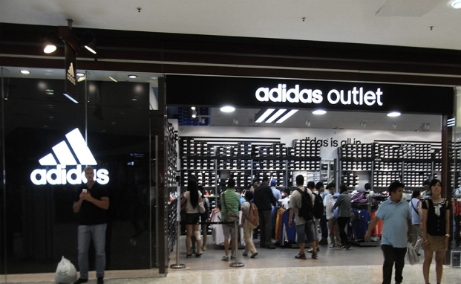 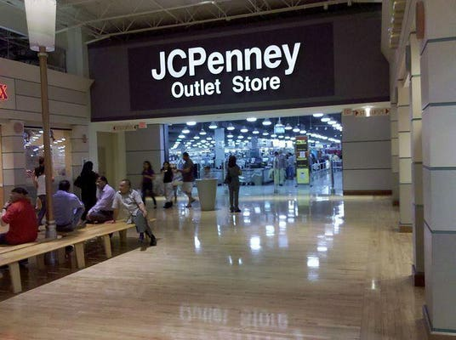

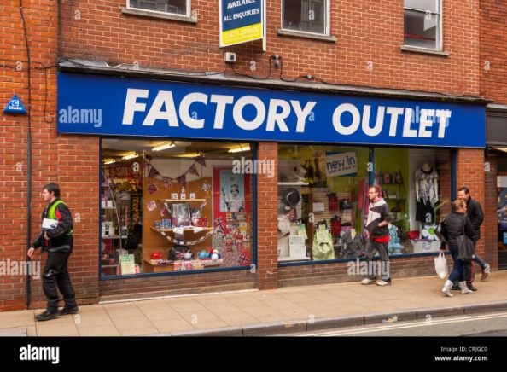 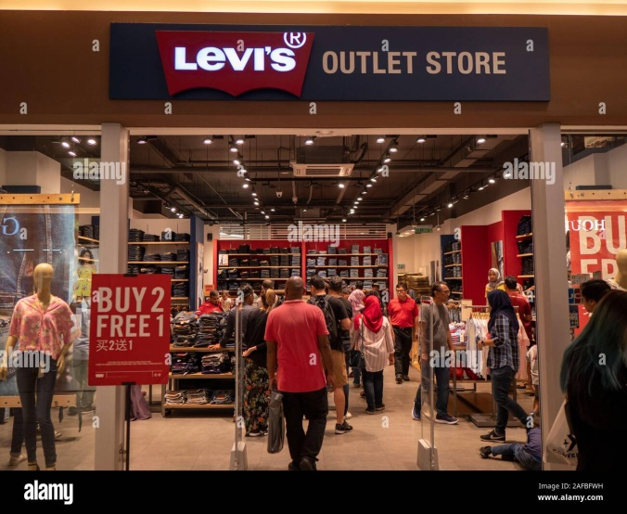

**Online:**

Online is sales of goods and services conducted through the website

 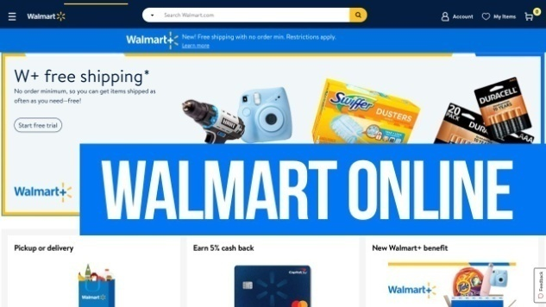

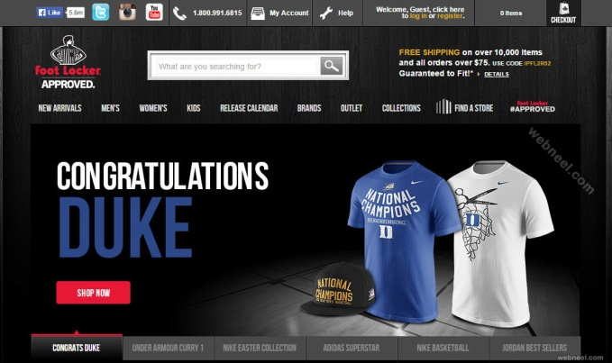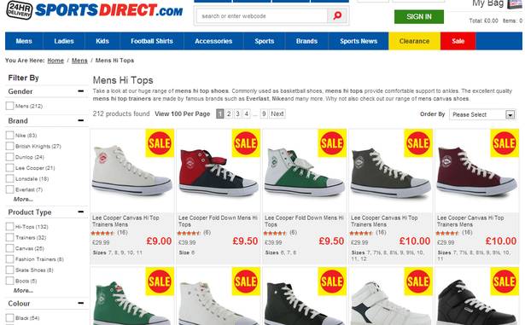

The above are the example pictures of online sales.

**In-Store:**

In-store means the sales of goods and/or services through the use of a program card at any merchant location (or) happening/existing inside a large shop, or available for customers to use or buy inside a large shop.

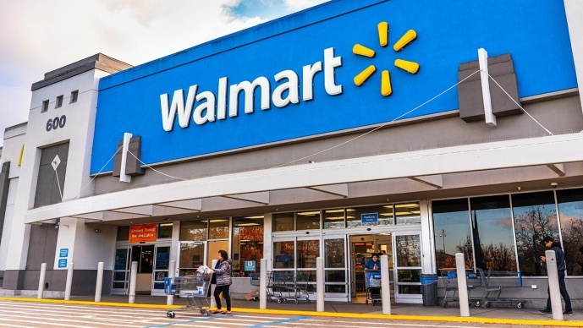 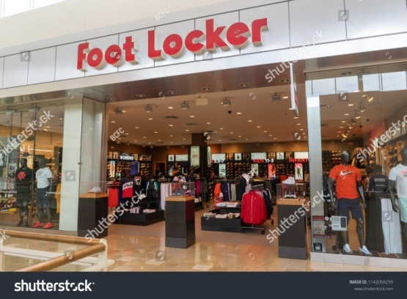

**TOOLS USED FOR THIS PROJECT/ANALYSIS:**

The below are the tools which I have used in this project

* Anconda Navigator’s Jupyter Notebook for Python
* SQL lite (online compiler)
* Tableau Public (for visualizations)

**UNIFIED MODELLING LANGUAGE DIAGRAM**

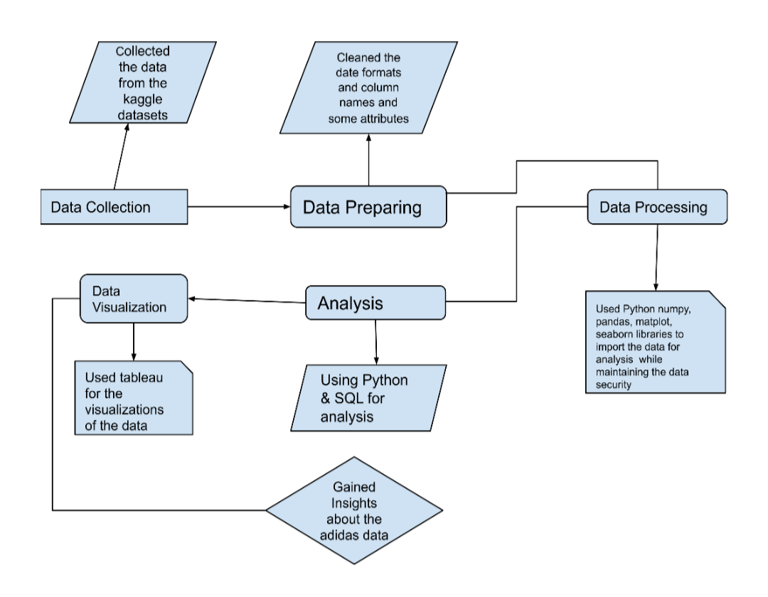

**ANALYSIS**

The Data Analysis have six phases, they are Ask, Prepare, Process, Analyze, Share and Act.

**ASK:**

* The below are the questions which have been asked about the adidas dataset:
* How the Operating profit and Operating Margin have been calculated?
* How many retailers are there for adidas?
* What is the business problem?
* How the Retailer Id has been assigned?
* What is the difference between Total Sales and Operating profit?

**PREPARE:**

In prepare phase we model the data i.e, a model that is used for organizing the data elements and how they relate to one another. In the data modeling we have three types such as Physical data modeling, conceptual Data modeling, Logical data modeling.

Here the below points are the data modeling that we have done in our project.

* In the Adidas dataset we have Retailers and Retailer Id where the retailers have been assigned with some ids
* The city and column have arranged in a way that from those cities and states the retailers have been purchased the products
* Price per unit and Unit sold are the columns which says about the how many products have been purchased by the retailer for what price
* Total sales is the column which the retailer has given amount for that particular product
* Operating profit is the actual profit the Adidas company has gained excluding the manufacture cost.
* Operating Margin is the column where total sales is divided by Operating profit
* Sales Method is the column which says that the Retailers has an in-store, outlet, or online platform

**PROCESS:**

In the process phase we clean the data, Data manipulation, validate/ checked the consistency of the data, and transformed the dirty data to good data

Here are the changes we have done in our adidas dataset:

* We checked for the duplicates and our dataset doesn’t have any null values.
* I have changed the column Id’s (replaced the spaces with underscores) to make it easy whenever I call that column name.
* Removed the dollar symbols in Price per unit, Operating Profit and Total Sales columns.
* Changed the data type of Operating Margin to float(removed the percentage symbols)
* Converted the float type in the price per unit column to round integer.
* In the adidas dataset the Invoice date column doesn’t have the proper consistency, so we transformed the date formats in one format by using python.
* Removed the commas in the columns Unit Sold, Total Sales, Operating profit and apostrophes (‘) in products.
* We checked the values of Operating Profit and Operating Margin to assure that the whole two columns have the no wrong data. After checking that we found that our data doesn’t have any wrong data in those two columns.
* We checked whether the Price per unit column have any wrong data or data inconsistency and there is no data inconsistency.

I have used python and excel for process phase. After the completing the process phase we moved to analyze phase.

**ANALYZE:**

For analyzing the data I have used Python and Structured Query Language (SQL). After analyzing the adidas data, I have used Tableau to present my dashboard.

**SHARE:**

The below is the dashboard which I have created from adidas sales data of US.

I have used Bar graph to show the change between the sales of the year 2020 and 2021 refer the bar graph of (2020 vs 2021). Maps showcase the data of US that which city has the highest profit. The darker the region the higher the profits Bubble chart shows that which retailer has the highest profit, and the last Bar graph is used to show which product gave the highest profit.

**DASHBOARD:**

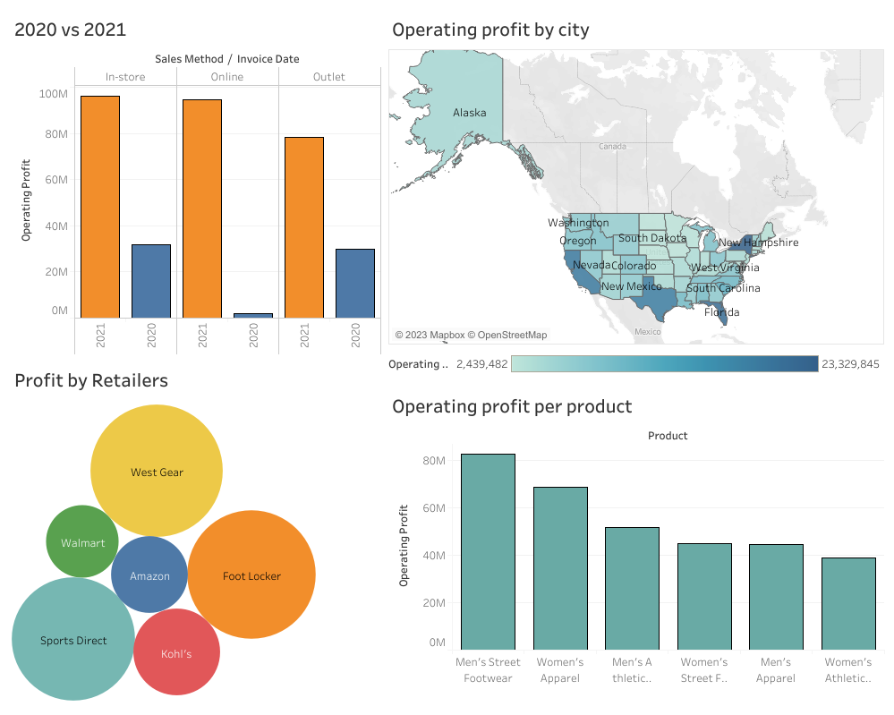

**INSIGHTS:**

Below are the insights that I have drawn from the adidas dataset:

1. The highest number of products has been sold to the states of **TEXAS** and **CALIFORNIA**
2. The lowest number of products has been sold to the state Alaska and that is Men’s Apparel and Women’s Athletic Footwear.
3. The highest number of products has been sold to the city **PORTLAND.**

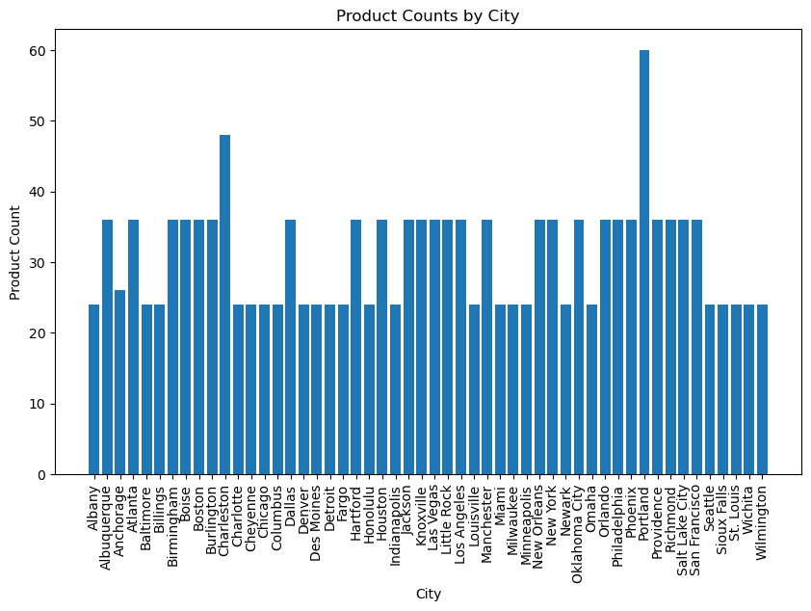

1. The highest number of products has been sold to FootLocker Retailer

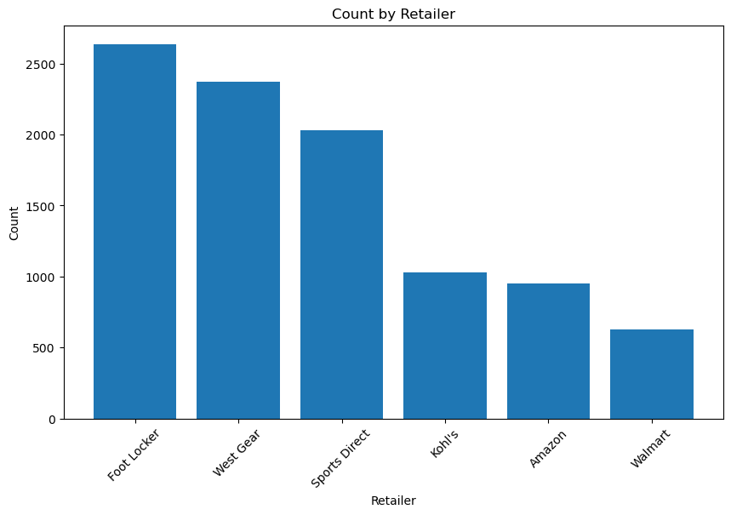

1. The majority of the Americans prefer shopping in online over in-store and in outlet.

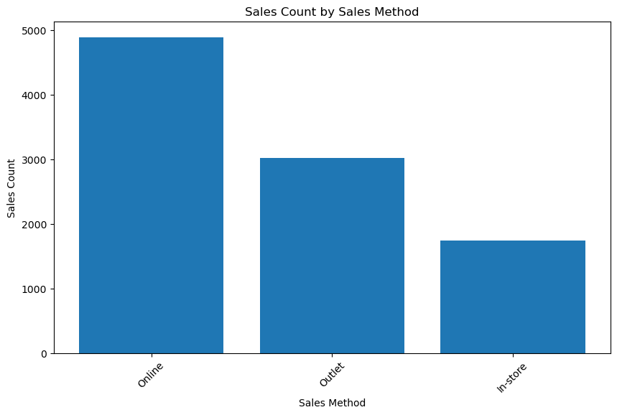

1. According to the entire dataset, Adidas manufactured more footwear for men, including athletic footwear, and the most sold and profitable product is also Men’s Street Footwear.
2. In the United States 38.4% of all the athletes are women, while 61.6% are the men Athletes, That may be the reason why we(adidas) have the less profit in Women’s Athletic footwear (increase the sales in Women’s Athletic Footwear.)  
   **Solution:** By increasing the awareness among the US women and creating the positive and inspirational view on the women players of US through an advertisement can increase the sales of the women Athletic Footwear.
3. West Region, Charleston City and West gear Retailer has the highest profits but Midwest Region, Walmart Retailer and Omaha City has the lowest profits.
4. We have the data of 2020 and 2021, from the data adidas got more profits in 2021, in the month of October and got least profits in the year 2020 in the month of November.  
   **Reason:** In the November month of 2020 Texas, California, Nevada, Oregon, Maine, Idaho, New Mexico, Ohio, Pennsylvania, New York and many more states has the highest covid patients record and deaths, so there is a lowest profit.
5. In the month of September 2021 US declared covid vaccines and vaccination made compulsory to all the Americans that might have made decrease of covid patients records and deaths in the October month, that might be the biggest reason for the highest profit compared to the year 2020.
6. Amazon Retailer has the lowest unit sales while West gear has the highest Unit sales.
7. Amazon has started to buy the products of adidas from the year 2021.
8. In the year 2020 people most choosed In-store and Outlet rather than Online and in the year 2021 people most chosed In-Store than online or outlet.